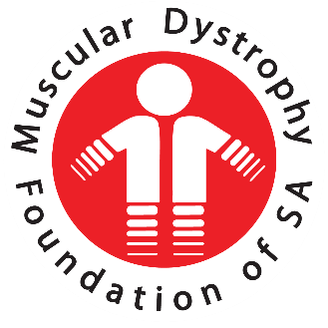
  - Annual Report Oct 2021- Sept 2022
  - Muscular Dystrophy Foundation of South Africa, Western Cape

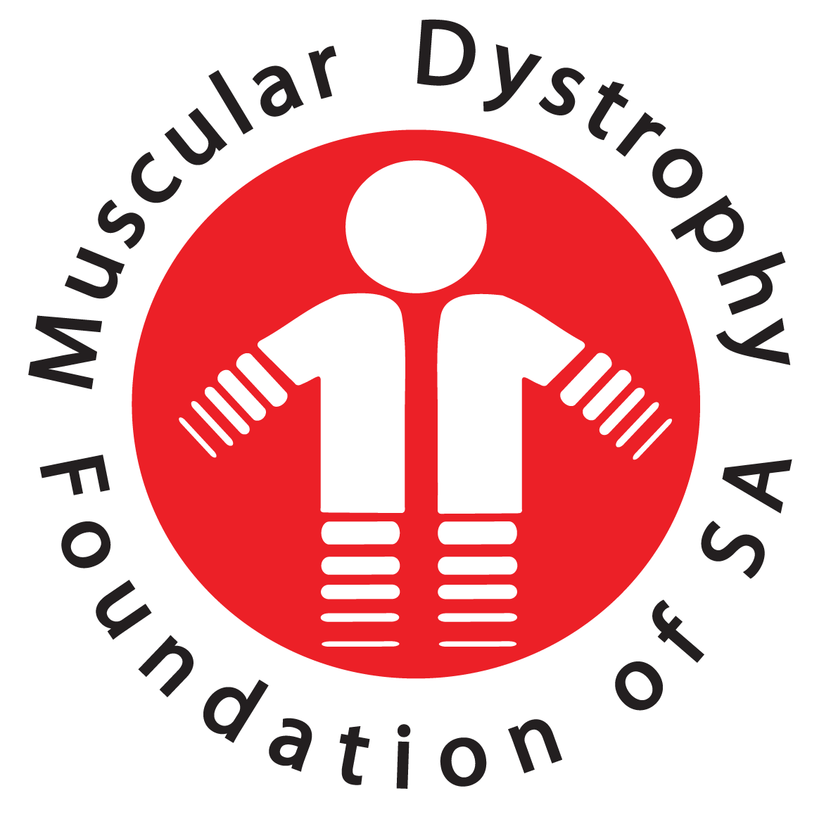

27th Annual Report
  - Muscular Dystrophy Foundation of South Africa, Western Cape

Welcome everyone and thank you for taking the time to join us this morning.

Last year we had our branch AGM at 10:00 and our national AGM at 11:00 via Microsoft Teams and will be doing the same this year.
You are invited to stay online and join us for the national AGM meeting, which should not be longer than an hour.

CHAIRMAN’S REPORT

OFFICE AND STAFF
Fortunately, we were able to resume some of our services within the community as Covid-19 restrictions were lifted. We could once again move back to visiting schools and hospitals. It was also with great joy that we could resume Adult Support Group meetings as well as Parent support meetings. Not being able to meet together left a huge void within the outreach programmes of our counselling staff.

COUNSELLORS
In January one of our counsellors, Mariam Landers requested that she be allowed to leave our services urgently as she needed to be care-giver to her invalid mother. Mariam had been such an integral part of our counselling team that it was difficult to say yes but it was absolutely the right decision. In her place we were able to appoint Tersia Charles who has slotted into the counselling team beautifully and is a perfect fit for our team. Tersia has filled the counselling staff back to a team of four again. She joined Babalwa Matya, Samantha Muller and Nomfundo Faku.

OFFICE CO-ORDINATOR
Dianne de Graaf has left our employ and I’m sad to say, left many problems behind and many tasks not completed. One of the main things being our Lotto applications for the past two years have not been submitted. This has serious implications for our branch as we’ve had no funds for any type of equipment either for our members or for upgrading office needs and fulfilling outreach programmes. However, we have struck gold in acquiring the services of Mandy le Bruyns as our new Office Co-ordinator. I would like to officially welcome her to the Cape Branch. She joined us on 15th August and has been thrown into the deep end as the saying goes. In the short time she has been with us, she started sorting out our admin and managed to get our A.G.M. ready for today. Really, well done Mandy and thank you for joining our team and your great work getting us ready for this meeting today.

SERVICES AND SUPPORT
As mentioned previously we have once again resumed Support Group Meetings, visits to schools and hospitals. The counsellors have been busy arranging various support group meetings, parent meetings etc. and as this is Muscular Dystrophy Awareness month we’ve once again gone green. You might have noticed on Facebook various get togethers’ with everyone looking charming in green. The various activities will be listed in the counsellor’s report.

BRANCH ACTIVITIES
BARGAIN SHOP
The volunteers have once again got the shop up and running and have raised R11 267.00 in the short time they’ve been able to operate. A sincere thank you to our hardworking volunteers who give up their time on Fridays to sort donations and serve customers.
Severe winter storms in Cape Town always add to our woes and once again our bargain shop at the back was flooded. This in spite of the fact that we have laid in additional drainage at the back of the building. When the municipality does not keep Voortrekker road clean unfortunately there is a push back of water which runs down the driveway to the back of our property which is very frustrating. This is a problem along the length of Voortrekker road. Fortunately, our offices are never affected but it calls for serious time-consuming clean-up operations.

FUNDING

LOTTO FUNDING
I am embarrassed to have to report that there has been no Lotto funding for the past two years because we have not submitted an application.

DEPARTMENT OF SOCIAL DEVELOPMENT
We are extremely fortunate to have received funding from the Department of Social Development for the amount of R680 842.00. This funding is salaries for our social services staff with a small amount included for administrative costs.
We affiliate ourselves with the Department of Social Development and this affords us opportunities for outreach programmes, using some of their services within the community. It is mandatory for the Department of Social Development to undertake an audit of our financial statements and conduct an onsite visit. This is a very thorough audit and we pride ourselves on being a well-structured, transparent, non-discriminatory and fair organization that strives to improve the lives of anyone who has Muscular Dystrophy. Regular feedback in the form of quarterly progress reports to the Department of Social Development is therefore important to retain this subsidy.

WHEELCHAIR AND EQUIPMENT REPAIRS
In spite of sever financial restrictions we have managed to fund wheelchair maintenance and repairs to the amount of R49 567.70

EQUIPMENT SUPPLIED
We were able to supply 2 bipap machines to members and 1 new wheelchair to a young man who lives in Clanwilliam. The wheelchair donation was made possible by an anonymous donor who met this youngster at Red Cross Children’s hospital and wanted to assist him. We were incredibly humbled by this generosity of spirit. We’ve given this youngster the means to keep up with his friends and develop his full potential.

DONATIONS
We received a generous donation from Hollywood Bets of: 1 laptop, 1 printer, 3 heaters and 1 office chair.

FUNDRAISING
Our shared golf day with the Goodwood Rotarians is scheduled for the 21st October 2022. We are in need of 4 ball prizes and anyone who can assist with prizes can let the office know. Last year we raised R15 000 on our shared golf day.

COMMITTEE
My sincere thanks to the committee for your continued loyal support of our organization.

NATIONAL
I would also like to thank our National EXCO chairperson and committee for their assistance and support throughout the year.
A special thank you to Gerda Brown for her guidance and ongoing training sessions for our staff as well as Sarie Truter for her support.

WIN VAN DER BERG
CHAIRPERSON

SOCIAL WORK REPORT

Introduction
It is a great pleasure for me to be presenting the social work report for the period October 2021- August 2022. It has been a year with lots of challenges from the outbreak of Covid 19, high inflation rates, high GBV rate in our communities, and job instabilities as many people lost jobs during the Covid 19 pandemic.
The following report shows the services that were rendered by the Social Work Services department- Cape Branch for the period stated above. Such services are as follows:
- Casework
- Group work
- Adult & Children Support Groups
- Awareness campaigns

Casework
Social Work Staff facilitated counseling services to clients, families, and their significant others in the office, hospitals when they meet them on days of their clinic appointments, and also at support groups whenever a need arises. The Social Workers with the help of the Social Auxiliary Workers try their utmost best to make sure the social, emotional, and psycho-social needs of clients are met. Currently, the Cape branch has a total number of 619 which is made up of 400 registered members and 219 pending cases.
Between September and August 2022, 14 new members have been registered and 5 cases closed (RIP). The Social Services staff has offered casework services to 1 319 families in a form of office/ telephone contacts and home visits. An average number of 109 families were contacted each month to make regular check-ins and to offer support whenever such a need arises.
Social Workers work closely with the Neuro-muscular clinic at Red Cross Children’s Hospital and Tygerberg hospital. It is where they get to interact with MDF clients and also get new referrals from doctors at the clinic. The Red Cross Children’s Hospital is attended by 1 Social Worker with one Social Auxiliary Worker each Tuesday of the week. Tygerberg Hospital is twice a month.
Red Cross Children’s Hospital
Between September 2021 and August 2022, 24 Neuro-Muscle clinics were attended, and interaction with 85 families at the clinic was made.
Tygerberg Hospital
During the reporting period, 10 Neuro-Muscle clinics were attended, and the social workers got an opportunity to interact with 25 adult clients and 7 families.
LSEN schools
The social workers have visited schools where MDF clients attend to interact with and offer psycho-social support to them. Following is the list of schools:
Eros
Astra
Paarl
Tembalethu and
Vista Nova LSEN school

School Support Groups
The Social Auxiliary Workers facilitated support groups at the above-mentioned schools on Wednesdays each week and 24 support group sessions were achieved. A good working relationship also exists between the Muscular Dystrophy Foundation Cape branch and Jan Kriel LSEN school, AGAPE LSEN school, and Lentegeur LSEN school though the schools are not visited on a regular basis. Interdisciplinary services and care are facilitated and coordinated telephonically.
Tembaletu School Muscular Dystrophy Support Group
Group meetings are held on a quarterly basis at Tembaletu School. This group is facilitated by the Social Auxiliary Worker and a social worker for all clients with different diagnoses of Muscular Dystrophy attends. There were 3 sessions conducted within the reporting period. This group is effective and well attended. It focuses primarily on teaching life skills and skills related to condition management. This group plays a crucial role in evolving a support system for Gugulethu and Khayelitsha-based Muscular Dystrophy families.
Eros School Muscular Dystrophy Support Group
This program is held quarterly at Eros LSEN School and renders group work services to 6 children who all live with a different diagnosis of Muscular Dystrophy. This group is facilitated by the Social Auxiliary Workers and all learners with different diagnoses of Muscular Dystrophy attend. This group is effective and well attended. It focuses primarily on teaching life skills and skills related to condition management. It plays a significant role in managing the cases at Eros LSEN School and in identifying the individual support required. There were 4 sessions completed during the reporting period
Astra School Muscular Dystrophy Support Group
Group meetings are held on a weekly basis at Astra LSEN School. Between September 2021 to August 2022, the group had 10 members. The group focuses on the provision of therapy and life skills to all children affected with various types of Muscular Dystrophy. It plays a crucial role in managing the cases at Astra LSEN School and in identifying the individual support required. There were 17 sessions conducted during the reporting period.

Vista Nova MD Group
This group happens once in a term but unfortunately, there was no group session facilitated at the school during the reporting period since there were only 2 clients, and the school dissolved the support group.
Paarl School MD Group
This group is facilitated once a term by the Social Auxiliary Worker and a Social Worker. The group consists of 8 learners affected with various types of Muscular Dystrophy. The group work focuses on condition management and therapeutic life skills. There were 2 group sessions done for the reporting year.

Home visits
Home visits were conducted during this period but not to the maximum desire of the social workers due to the high rate of crime in some of the areas where our clients live and because some clients are not reachable telephonically to schedule appointments.

Office Counselling
Individual and family counseling services were offered to clients and their families/ their significant others as per their needs. During the reporting period, 13 counseling sessions were facilitated in the office. Some of our clients are not yet free to come into the office as they feel Covid 19 is still with us and continues to claim lives.

Telephonic and Email
Telephone calls have been one of the best ways of doing counseling during the time of Covid 19 outbreak as it was not always safe to schedule counseling appointments in the office for the safety of clients and staff.

Adult Support Group
It is exciting to note that as Cape Branch we managed to facilitate adult support groups for our clients during the reporting period. The first one was facilitated at Greenpoint Park. It was a way of taking our clients out of the stressful environment they have been in during the two
years of Covid 19 pandemic. The clients enjoyed interacting with each other and with the MDF staff as it was their first time to meet with them physically. All the MDF staff attended the Support Group session as they were looking forward to seeing their clients. The 3 other support Group sessions were facilitated in the MDF office, and they were all productive.

Children Support Group
3 Parent’s Support Group sessions were facilitated by the Social Worker with the help of the SAW in the MDF office. Parents were motivated and felt empowered by the group session as they shared their experiences on the care of their children. SW motivated them to keep on doing the best they do for their children and assured them of their support as the organization.

Community Work Awareness
Awareness was facilitated by the Social Auxiliary Workers at Goodwood mall. It was a great success as they managed to engage with the community members and do awareness of the different MD conditions.

Highlights
- The appointment of a new office coordinator brought much excitement into our office as there was a gap regarding administration services to keep the office up and running. In less than 3 weeks, the new coordinator managed to sort out some of the key areas that were left hanging by the previous coordinator.
- Unmeasurable support the staff received from our chairperson, Win van der Berg when the office operated without the coordinator and her continued support whenever a need arises. Her physical check-ins and telephone calls to see to it that everything in the office is in place have kept the staff motivated to do their best.
- Donation of a new laptop, printer, office chair, and 3 oil heaters by Hollywood Bets-Goodwood.

Challenges
- Old laptops that make it very difficult for the staff to do their work.
- Difficulty in finding placement for clients at residential care facilities due to long waiting lists and very few facilities accommodating clients with Muscular Dystrophy.
- Loss of clients due to their conditions.
- Funding

Babalwa Matya
Social Worker

