  - Annual Report Sept 2021- Aug 2022
  - Muscular Dystrophy Foundation of South Africa – National Office

Annual Report 2021
  - Muscular Dystrophy Foundation of South Africa – National Office

Contents
1. Mission Statement 2
2. About Us 2
3. National Chairman’s Message 3
4. General Manager’s Report 4
4.1. Governance 4
4.2. Strategic Objectives for 2020/21 4
4.3. National Service Delivery Programmes 0
4.3.1. Advocacy, awareness and public education programmes 0
4.3.2. Outreach to Members 2
4.3.3. General Operations and Management 3
4.3.4. Fundraising 4
4.3.5. Support and strengthen the social work support programme at branches 5
4.4. International collaboration 5
5. Contact Details 5

Mission Statement
The mission of the Foundation shall be to support people affected by Muscular Dystrophy and Neuromuscular disorders and endeavor to improve the quality of life of its members.

About Us
The Muscular Dystrophy Foundation of South Africa (MDFSA) is a registered non-profit organisation – Reg. No. 004-152 NPO – consisting of a national office and three branches which operate in the nine provinces of South Africa.

The Organisation was founded in 1974 by Mr. and Mrs. Newton Walker of Potchefstroom who, at the time, had a son affected with Duchenne Muscular Dystrophy. The Foundation was established with the aim of reaching out to other parents and families in a similar situation and to support research into this disease with the ultimate goal of finding a cure. The Foundation has been actively involved in carrying out this aim for the past 40 years.

The Foundation’s role within social integration, support services, Muscular Dystrophy awareness programmes and Muscular Dystrophy diagnostic research support is to:

- Enable people to participate in identifying Muscular Dystrophy needs and to respond appropriately.
- Develop equal caring and coping services for people affected by Muscular Dystrophy.
- Support affected people with specialised assistive equipment.
- Create public awareness on Muscular Dystrophy issues and disability.
- Strive for the recognition and protection of the rights of people affected by Muscular Dystrophy as a disability.
- Support and promote diagnostic research into the causes and treatment of Muscular Dystrophy.
- Generate funds to support and sustain our work.
- Collaborate and communicate on a national, provincial, international, governmental and non-governmental basis on policy matters relating to all aspects of muscular dystrophy.
- Assist individuals to form self help and support groups.

National Chairman’s Message

It is my privilege as Chairman of the National Executive Council of the Muscular Dystrophy Foundation of South Africa to submit the Annual Report for 2021/22. The report presents achievements recorded during September 2021 to August 2022.

In the absence of a cure for this condition, the Foundation historically emphasised psycho-social interventions that were aimed at enabling people who have this condition to strive to live a “quality” life; raising public awareness; assist with specialised disability equipment if funds are available; and maintain a register of people diagnosed with Muscular Dystrophy. To remain relevant and in line with international trends we included entering the arena of access to treatment, genetic testing, the establishment of support groups as well as building inter-national relationships and affiliations. The general manager’s report will provide more information on the progress of these valuable processes.

We are grateful to our valued and loyal donors, funders, and the individuals who, despite the challenging financial climate, continue to generously support us. Your support assisted us in delivering the much-needed services required by our members and their families. We trust that we can count on your continued support in the years to come.

We must always give special acknowledgement and thanks to our biggest financial partner, Crossbow Marketing for the partnership over many years. We would not be able be here today without this partnership and we thank the management and staff for their continual commitment and hard work in securing a constant income flow for the MDFSA.

I wish to acknowledge the contribution of our dedicated staff and management in all of our offices for their dedication, commitment and service in the interest of our incredibly special members.

In conclusion, appreciation is extended to the EXCO for your support and ensuring that we stay true to the mission of MDFSA. You are deeply valued, and we look forward to another year working together with you all to achieve our common goal.

Adv. Maatjan Ferreira

General Manager’s Report
I am delighted to present the Annual Report for the Muscular Dystrophy Foundation of South Africa for the period September 2021 to August 2022.

Governance
The Muscular Dystrophy Foundation‘s National Executive Committee was comprised of eight executive members representing each Branch in the following portfolios:
- Gauteng: Jan Ferreira (Chairperson), Masilo Motlautsi and Anri Human (Secretary).
- Western Cape: Win van der Berg (Vice chairperson), Anne-Marie Stoman and Gilda van der Merwe.
- KwaZulu Natal: Noel Pillay (Treasurer), Pamela Rapiti and Raj Mahadaw.

Strategic Objectives for 2021/22
Strategic Planning was conducted on 12 March 2022. The strategic objectives for the year were as follows:
- Strategic objective 1: To create advocacy, awareness and public education programs regarding muscular dystrophy.
- Strategic objective 2: Outreach to members.
- Strategic objective 3: Govern and manage the organisational structure of MDSA.
- Strategic objective 4: Fundraising.
- Strategic objective 5: Support and strengthen the social work support programme at branches.
- Strategic objective 6: To promote and support research into the cause, nature, treatment and cure of the disease.

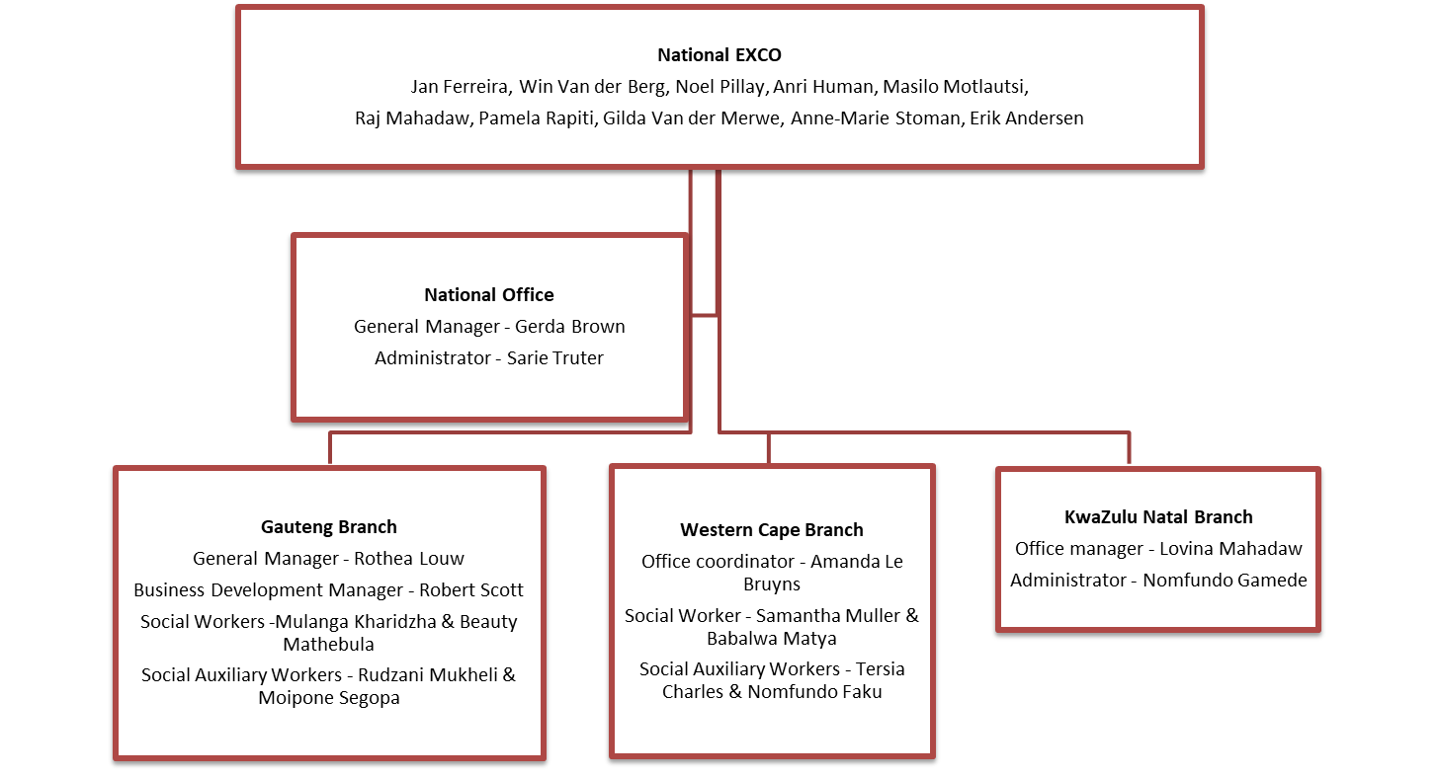

National Service Delivery Programmes

Advocacy, awareness and public education programmes
One of the most important roles of the National Office is informing and educating people about the work of the Foundation, Muscular Dystrophy and disability in general. In this reporting period MDFSA remained committed to sharing the message about Muscular Dystrophy to our communities.

Radio
Marinus Mans and Tasnim Casoojee (both MDFSA members) shared their journey with muscular dystrophy on Lotus FM. Another member, Andrew Millar was interviewed by Algoa FM to celebrate SMA Awareness Month. Thank you, Marinus, Andrew and Tasnim, for your willingness to share your stories with the public.

Sarie Truter, fundraiser at the National Office, also raised awareness about muscular dystrophy and the work that the Foundation does on Lekker FM.

Social media
Social media has become the pillar of online awareness programmes. In this reporting period the Foundation posted 122 updates on the MDFSA Facebook page, and our following grew from 1959 to 1991 followers.

The Foundation is also the proud owners of a YouTube channel where we post very interesting interviews with experts in the field of muscular dystrophy, as well as life stories told by some of our members.

Our website is also updated regularly to keep it interesting and current. Please view our website at www.mdsa.org.za.

Public awareness
The Foundation celebrated International Muscular Dystrophy Awareness Month during September by running the “Get into the Green Scene” campaign for the fourth consecutive year. This campaign is our signature social media event to recognize Muscular Dystrophy Awareness Month. The campaign is designed to stand out on social media by combining the campaign’s official colour (green) with an eye-catching image. Affected members, their friends and family as well as various corporates participated in the campaign by posting their “green” photos on the MDFSA Facebook page. We had a very successful campaign with many new faces participating.

This year the office also went green. A big thank you to Greg Bouwer and Dominic Brown who put up the lights and banner for MDFSA.

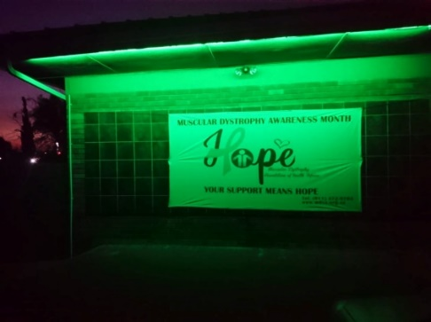
MDF Rocks
This campaign was initiated to include children during MD Awareness Month by doing a fun activity. We received very interesting, artistic rocks.

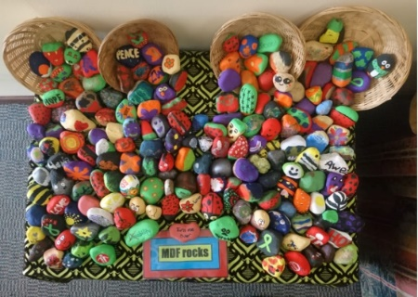

Celebrating awareness days/months
Raising awareness is very important to the Foundation. Our role is inter alia to dispel the lack of knowledge, mythologies and stigma around disability and muscular dystrophy. This is achieved by allowing our affected members to share their journeys on specific awareness days. In this reporting period selected members have been interviewed about living with muscular dystrophy. The recordings of the interviews are available on the MDF Facebook page and YouTube channel.

A special thank you to Marinus Mans for conducting the interviews with so much compassion and letting our members feel at ease to share their stories.

Spinal Muscular Atrophy (SMA) awareness
Like many rare diseases, there are many misconceptions about SMA. Most people are not familiar with SMA until a family member or friend gets diagnosed with it.

In partnership with Roche, MDFSA rolled out an awareness campaign specifically targeted at SMA. The campaign targeted the general public, persons affected by SMA, medical professionals and LSEN schools.

Knowing the facts about the disease will go a long way in understanding the condition and how to speak to others about it.

A heartfelt thank you to Andrew Millar and Marinus Mans for their insightful advice in the development and implementation of this campaign.

Thank you also to Roche that made this campaign possible and for believing in us to do the campaign justice.

Outreach to Members
The Foundation’s role within social integration and support services is mainly to provide support to members affected by Muscular Dystrophy and their families. Support is largely provided by means of psycho-social support, provision of assistive devices and dissemination of information.

MDF Magazine
The Foundation distributes an e- magazine to our members, medical professionals, as well as national and international NGOs three times per year. The aim of the magazine is to keep members informed of all activities and research on National and International stages.

Thank you to everyone that contributed the insightful articles to our Magazine, as well as the companies that placed advertisements.

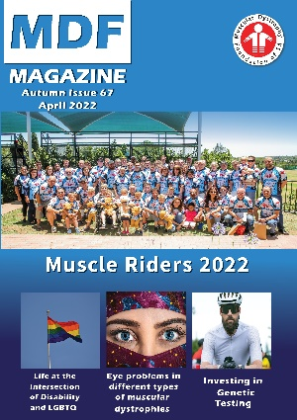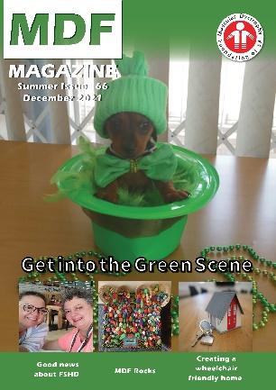

Genetic testing
A working relationship was established with Dr Peter Jones from the University of Nevada with regards to genetic testing for FSHD. FSHD testing is not available in South Africa at all. Dr Jones completes genetic testing worldwide, at no cost, as part of a research study. In this reporting period 23 members clinically diagnosed with FSHD has been assisted to confirm their diagnosis genetically.

Our gratitude must be extended to Peter Blackburn who initiated a fundraising project to cover the courier fees to Nevada.

Inter-national collaboration and support groups
MDFSA realised that not all our members require psycho-social intervention and emotional support. Many of our members decline any form of support services. These members express that access to the latest information with regards to research and treatment as their paramount need.

Very little information is available in South Africa and therefore working relationships were established with international organisations which specialize in specific types of muscular dystrophy. MDFSA is now affiliated with the World Duchenne Organisation, World FSHD Alliance, LGMD Awareness Foundation and TREAT-NMD.

The Foundation attended the Action Duchenne Conference, LGMD Summit as well as the FSHD Summit in this reporting period.

In conjunction with our members, support groups were established for FSHD, LGMD, DMD and SMA. The efforts of Mina Du Plessis, Erik Andersen and Christel Rohrs, for coordinating these groups, are applauded.

Webinar
In October 2021, MDFSA hosted their first webinar. The Webinar addressed topics such as:
- Who do you need in your neuromuscular team?
- The emotional journey from diagnosis to acceptance
- Genetics testing in South Africa
- How to maintain disability equipment
- The COVID vaccine and muscular dystrophy
- What you should know about your taxes

A special thank you to all the speakers for their insightful contributions to the webinar. All the attendees gained valuable knowledge and certainly have a better understanding of muscular dystrophy.

We hope that this webinar will be the first of many in the years to come.

Access to treatment
A working group was established during April 2022, comprising of MDFSA employees and members, to liaise with the Department of Health in the development of a Genetic Disease Policy Framework. This Policy will enable affected persons to access treatment in South Africa as it becomes available. We understand that this will be a long-term process, but so worthwhile for our members.

Thank you to our very special members Andrew Millar, Marinus Mans and Philip Kraft who is taking every step of this journey with us.

Assisting members with medical scheme benefits
MDFSA has started a process of supporting our members in improving their access to health care benefits from medical schemes. We approached the Council of Medical Schemes (CMS). Our goal is to gain further information as to why, despite Muscular Dystrophy being acknowledged as a PMB, many do not have their health needs covered by their medical schemes or are covered insufficiently. In order to represent our membership appropriately, we requested our members to share rejection letters from their medical schemes declining applications for services such as physiotherapy, disability equipment, medication, care givers, etc.

General Operations and Management
Policy development
The nature of our organisation demands that certain systems and policies, and procedures are in place. The policy relating to Equality, Diversity and Inclusion was drafted and the COVID 19- and Management of the Membership Database policies were reviewed.

Member database
The new database (ODI – Online Database Initiative) went live in November 2021 and was rolled out to all the branches. Thank you again to Eric Andersen who stepped in to develop the database and maintaining it together with Trishan Valodia.

A special thank you must also be extended to Mr Laurence Milner from CEEI for hosting our database free of charge.

Treat-NMD
MDFSA’s application to become a member of the TREAT-NMD Global Registry Network was approved late 2021. This will enable us to collect information for the core datasets for DMD, LGMD and SMA (Datasets for FSHD is in the development stage.) These datasets are a minimum, standardized core set of information that are not only useful for planning clinical trials but also recruiting patients into the trials, as well as helping researchers to answer questions such as how common the individual diseases are across the world and support other activities to improve patient care, such as the assessment of care standards in different countries.

The Foundation was also invited to apply for a bursary to assist with the collection of information for the SMA dataset. I am happy to report that a bursary of €8 000 was awarded in January 2022 to assist with the implementation of the SMA dataset. The funding is being utilised for the stipends of the project manager and curator, and the bulk is ring-fenced for genetic testing. Our appreciation must be expressed to Erik Andersen for managing this project soefficiently.

All members diagnosed with SMA are urged to please take advantage of this opportunity.

Fundraising
Crossbow Fundraising Campaign
Crossbow Marketing Consultants (PTY) LTD remains our greatest funder. Since 1988 Crossbow has been assisting us to raise funds by designing, manufacturing, marketing and selling various products for and on behalf of MDFSA.

We wish to thank Crossbow for their unwavering support. The income generated by them allows us to work towards the goals of our organisation and we truly see this partnership as essential to our survival and longevity.

Donations
We appreciate and give thanks to the individuals and companies for their kind donations. Support of the Muscular Dystrophy Foundation makes it possible to provide a service and support structure to families affected by this crippling and often fatal disease.

In particular, we wish to single out the National Lotteries Commission, Separations, FC Robb Charitable Trust, Roche and Newcastle University (UK) for their kind grants/donations.

MDFSA merchandise
The national office has a range of merchandise for sale as a fundraising campaign.

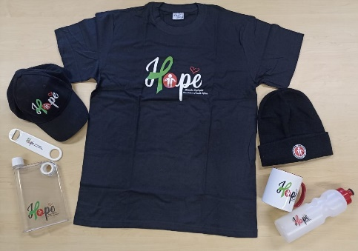

Support and strengthen the social work support programme at branches

Psycho-social support services and the provision of assistive devices to affected members are provided by the three branch offices. Detailed information regarding the social work programme is available in the annual reports of the branches.

However, in terms of the Social Service Professions Act (110 of 1978, as amended) all social service professionals are required to work under the supervision of a senior social worker. Due to financial challenges and the subsequent absence of supervisory posts on branch level, it is the role of the National Office to oversee the social work programme and provide guidance to the social service professionals.

International collaboration
The Foundation is affiliated to the following international Muscular Dystrophy organisations:

- World FSHD Alliance - The World FSHD Summit was attended on 26 & 27 June 2021.
- Action Duchenne
- Limb girdle muscular dystrophy Awareness Foundation
- Treat NMD

Contact Details

National Office
12 Botes Street, Florida Park
Tel 011 472-9703

Gauteng Branch
12 Botes Street, Florida Park
Tel 011 472-9824

KZN Branch
Office 7, 24 Somtseu Road, Durban
Tel 031 332-0211

Cape Branch
3 Wiener Street, Goodwood
Tel 021 592-7306

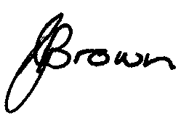
Gerda Brown
General Manager: National Office

